**NHL Data Analysis Project: Debugging Tool & Feature Ideas**

**Q2.1: Our Interactive Debugging Tool**

For our project, our team built an interactive tool to help us explore and understand NHL play-by-play data. It's like a custom dashboard that lets anyone on the team dig into the specifics of any game.

**What We Built:**  
The interface has a few key parts:

* **Dropdown Menus:** We can select a season (from 2016 to 2023), the type of game (regular season or playoffs), and then a specific game from that season.
* **Event Slider:** A slider lets us scroll through every single event in the selected game, one by one.
* **Three-Panel Display:**
  1. **Ice Rink Diagram:** A drawing of a hockey rink where events are plotted. We color-coded them: blue dots for shots and red stars for goals.
  2. **Full Event List:** A simple list showing all the events for the game, just like in the raw data.
  3. **Selected Event Details:** A box that shows all the info for the event we currently have selected, like the players involved, coordinates, and our calculated distance to the net.

**Why We Built It:**  
The main purpose was to act as a debugging tool for the team. While working with the NHL data, we needed a way to check if our calculations (like mapping coordinates or calculating shot distances) were actually correct. Seeing the events on a rink makes it much easier to spot mistakes compared to just looking at numbers in a spreadsheet.

**A Big Challenge We Faced:**  
One of the trickiest parts was calculating precise shot distances. The NHL data gives us the (x, y) coordinates of a shot, but it doesn't tell us which net the player was shooting at! This is a real problem for shots taken near center ice, where it's unclear which goal the player was targeting.

**Our Solution (And Its Limitation):**  
To solve this, we implemented a team-period approach. Basically, we look at where most of a team's shots come from in a single period and assume that's the net they are attacking.

A screenshot of our interactive debugging tool showing the rink visualization and event list:

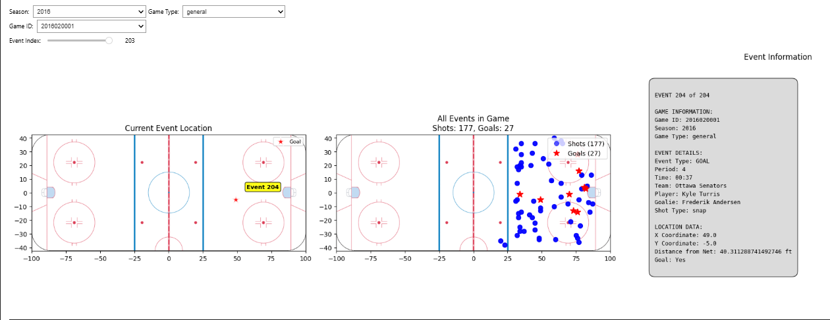

**Q4.1: Dataframe Example + Strength Analysis**

**What Our Data Looks Like:**

**How We Could Add Strength Information:**  
To track game situations like 5-on-4 power plays or 5-on-3, our team discussed a few ideas. We would need to:

1. **Track Penalties:** Follow penalty events to know exactly when a player is in the penalty box.
2. **Use Shift Data:** If we had it, we could count how many players are actually on the ice for each team at any given moment.
3. **Combine Game Context:** By putting penalty and faceoff data together, we could reconstruct the game state to know if a shot was taken during an even-strength or special teams situation.

This would be a great next step, as it would require us to work with more event types beyond just shots and goals.

**Q4.2: Three Potential Feature Enhancements**

Our team brainstormed several new features we could build to get more insight from the data. Here are our top three ideas:

**1. Rebound Detection**

* **The Idea:** Automatically identify shots that are rebounds from a previous save or miss.
* **How We'd Do It:** We would look for sequences where the same team takes another shot very quickly (e.g., within 2-3 seconds) after the first one.
* **Why It's Useful:** Rebounds are high-danger scoring chances. Flagging them would help us measure which teams and players are best at creating and converting on these second opportunities.

**2. Rush Chance Identification**

* **The Idea:** Detect shots that happen right after a team enters the offensive zone, catching the defense off-guard.
* **How We'd Do It:** We would look for shots that occur within a short time window (e.g., 4-5 seconds) after a recorded zone entry or a turnover at the blue line.
* **Why It's Useful:** This would help us analyze a team's speed and effectiveness in transition, separating "rush" chances from set offensive plays.

**3. Shot Quality Assessment**

* **The Idea:** Create a single metric that estimates how dangerous any given shot is.
* **How We'd Do It:** We would build a model that combines several factors: the shot's distance from the net, the angle to the center of the goal, the type of shot (wrist, slap, etc.), and maybe the game situation.
* **Why It's Useful:** Not all shots are created equal. This would move us beyond just counting shots and let us analyze the *quality* of scoring chances, which is a much better predictor of success.